**1.INTRODUCTION**

**1.1 Introduction & Objectives**

EduManager is a web portal that helps educational institutions for maintaining digital records.

* Helps to store large amount of student details
* Helps to retrieve large amount of student details

**1.2 Purpose of the Project**

The purpose of this document is to present a detailed description of EduManager. It explains the feature and requirements, functionalities, interfaces and how the system interacts (or) responds to users.

This document is designed to solve as basic for both developers and end users and the society for it’s appear. This is a software system which is developed for storing and retrieving the data.

The issue of maintaining records is very paramount in any organization, especially for educational organizations.

Manual maintenance of records is time taking and hectic.

Also there is a high probability of errors involved in manual record maintenance.

Therefore we intend to make the record keeping easy by the use of ‘EduManager’.

EduManager is a web portal which helps you to maintain large number of records of students in your educational organization.

It helps in keeping track of the fee structure of each and every student, to segregate the students who have cleared their fee payment and those who are yet to do so. It also calculates the fine based on the delay made in the payment.

It is designed to work on multiple platforms and supports all modern browsers. In short it helps to organize, summarize and maintain the records in an effective way.

**1.3 Existing system & Disadvantages**

**Existing system: -**

At present the student records are maintained manually in books. Each record is entered in the book and the records are retrieved whenever required.

**Disadvantages: -**

* It need a lot of human involvement
* Highly time consuming
* Large wastage of paper
* Retrieving is a difficult task when the number of records is high

**1.4 Proposed system with Features: -**

**Proposed system:-**

We propose a system which is user friendly.

Here we create a graphical user interface to visualize the data analyzed on timely basis.

Our project gives the visual representation of data that is analyzed from the database.

**Advantages: -**

* We propose a system which is user friendly.
* Here we create a graphical user interface to visualize the data analyzed on timely basis.
* Our project is very much useful in industries,colleges and more other places which store large number of records.

**2.SOFTWARE & HARDWARE REQUIREMENTS**

**2.1Software Requirements**

Operating system : windows

Client side technologies : JavaScript

Server side technologies : PHP

Database server : MYSQL

**2.2Hardware Requirements**

Processor : Pentium1v 600MHz or above Hard Disc : 30GB

RAM (SD/DDR) : 1GB

**2.3VisualizationTool**

Visualization tool : any web browser (IE6 or above)

**Compatible**: They can be used on any web browsers including explorer version6.

**3. SOFTWARE DESIGN**

**3.1. UML DIAGRAMS**

We have eight UML diagrams:

* Class diagram
* Use case diagram
* Sequence diagram
* Collaboration diagram
* State chart diagram
* Activity diagram
* Component diagram
* Deployment diagram

CLASS DIAGRAM:-

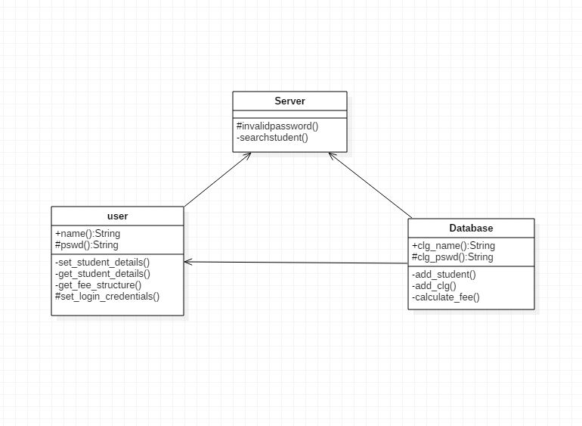

USE CASE DIAGRAM:-

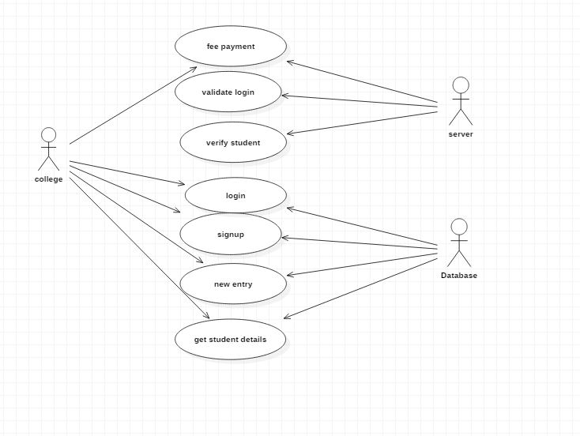

SEQUENCE DIAGRAM:-

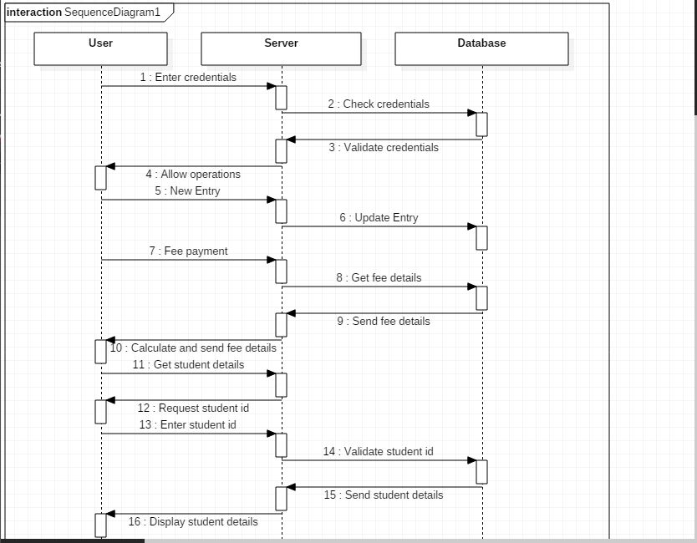

COLLABORATION DIAGRAM:-

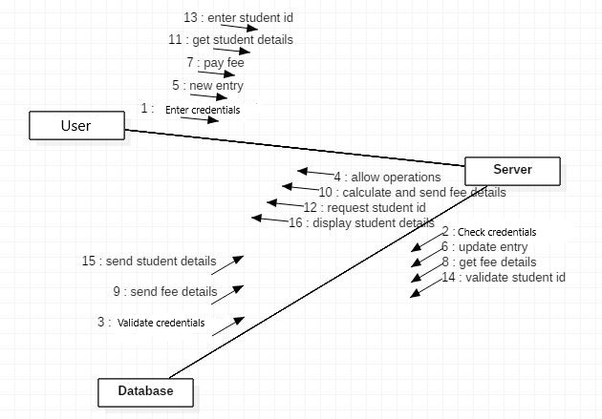

STATE CHART DIAGRAM:-

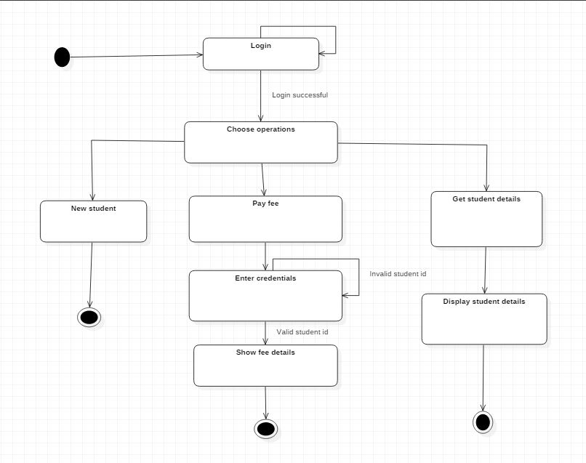

ACTIVITY DIAGRAM:-

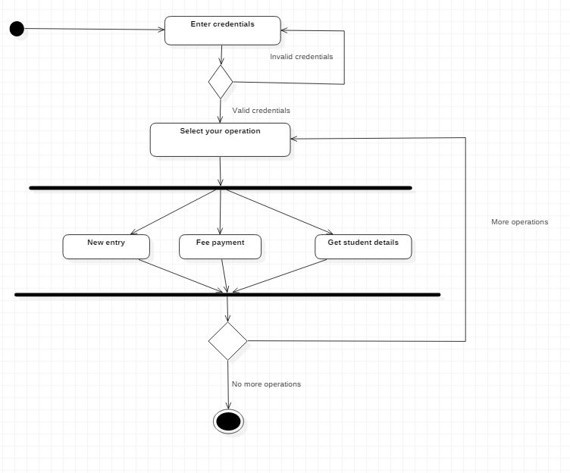

COMPONENT DIAGRAM:-

DEPLOYMENT DIAGRAM :-

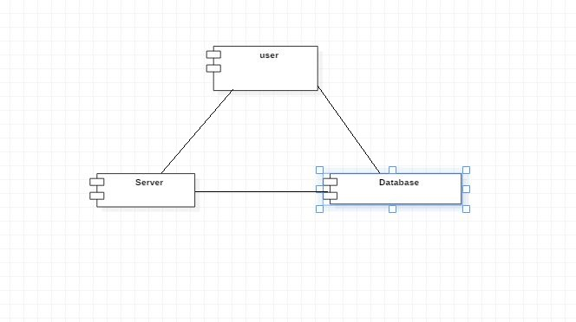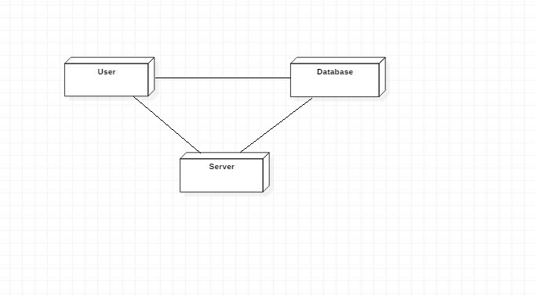

**4. CODING AND IMPLEMENTATION**

**4.1. Sample code:-**

<!DOCTYPE html>

<head>

<title>Edu Manger</title>

<link rel="stylesheet" href="css\\home.css" />

</head>

<body>

<h1 align="center" style="font-family:Times New Roman">Edu Manager</h1>

<hr>

<center>

<fieldset>

<form action="db1.php" method="post">

College name:<input type="text" name="clgname" required maxlength="40"><br><br>

Password: <input type="password" name="password" required><br><br>

<input type="submit" value="Login" name="login">

</form>

<input type="button" onclick="window.location.href='signup.html'" value="Signup" name="signup">

</fieldset>

</center>

</body>

</html>

<?php

$con=mysqli_connect('localhost','root','password');

$db=mysqli_select_db($con,"details");

if(isset($_POST['login']))

{

$clgname=$_POST['clgname'];

$password=$_POST['password'];

$clgname=stripcslashes($clgname);

$password=stripcslashes($password);

$clgname=mysqli_real_escape_string($con,$clgname);

$password=mysqli_real_escape_string($con,$password);

if($clgname==""){

echo "<script>alert('enter college name');</script>";

exit();

}

if($password==""){

echo "<script>alert('enter password');</script>";

exit();

}

else{

$res=mysqli_query($con,"select * from college_details where clgname='$clgname' and password='$password'")or die("Failed to query database ".mysqli_error());

$row=mysqli_fetch_array($res);

if($row['clgname']==$clgname&& $row['password']==$password)

{

header('Location:welcome.html');

}

else

{

header('Location:home.html');

}

}

}

mysqli_close($con);

?>

body {

color:indigo;

background-image:url("C:\\xampp\\htdocs\\edu manager\\images\\home.jpg") ;

background-size:100% 100%;

background-attachment:fixed;

}

**5.Working**

**Login page:**

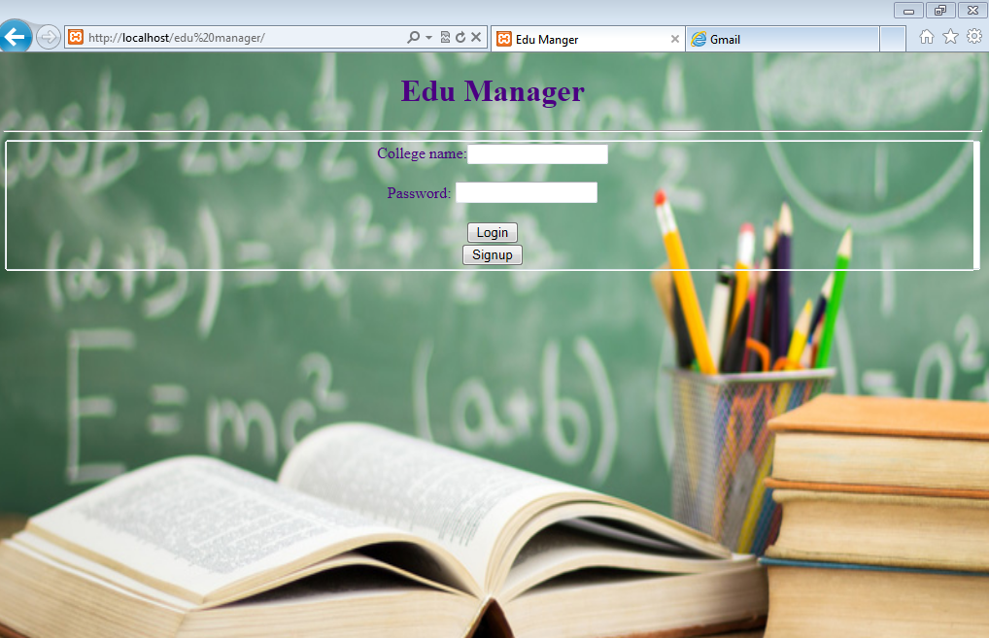

**Signup page:**

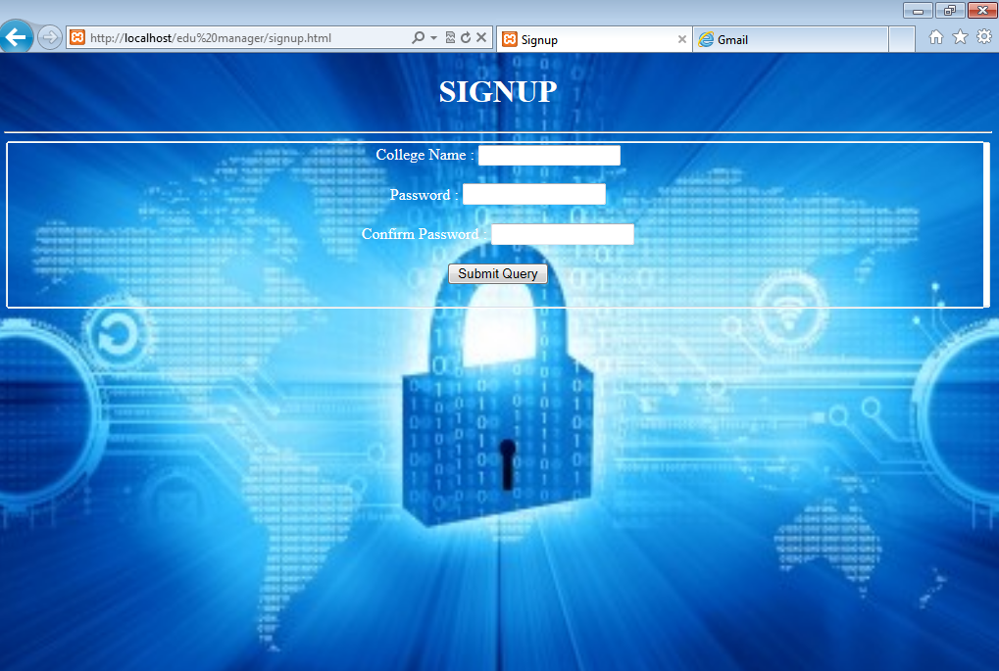

**Home:**

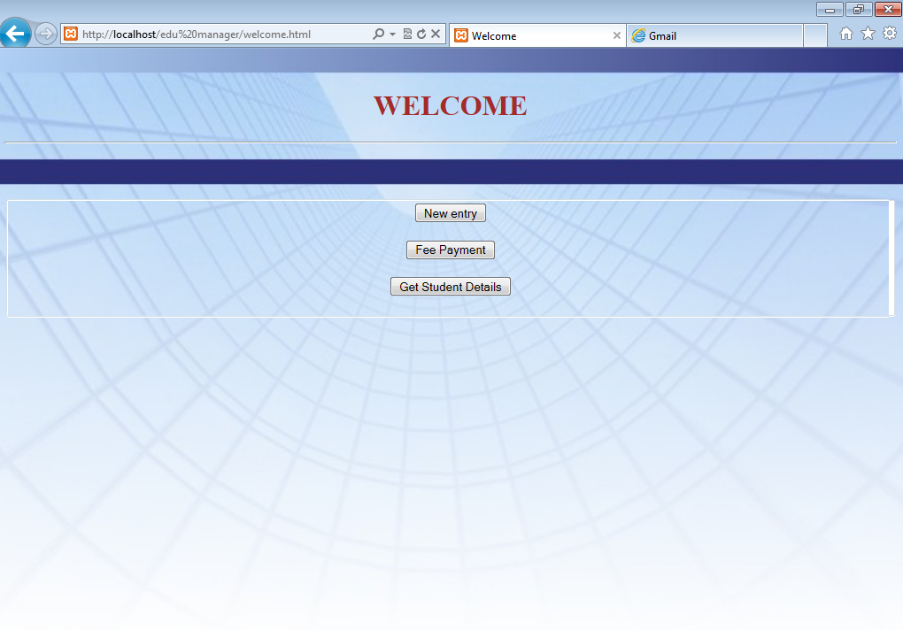

**New entry:**

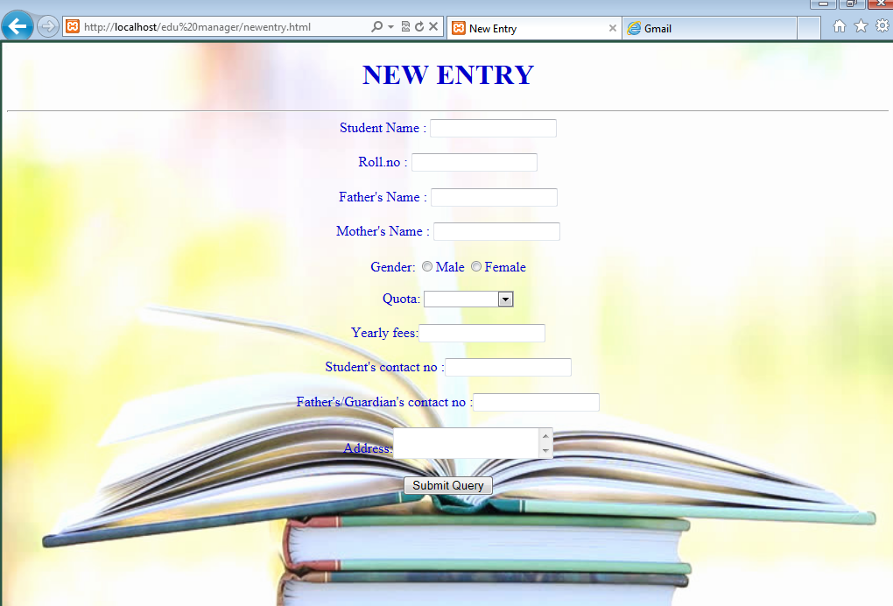

**Fee payment:**



**Student details:**

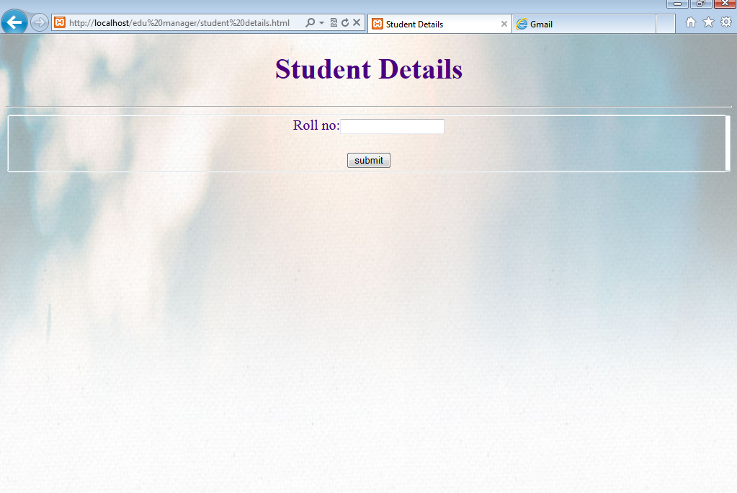

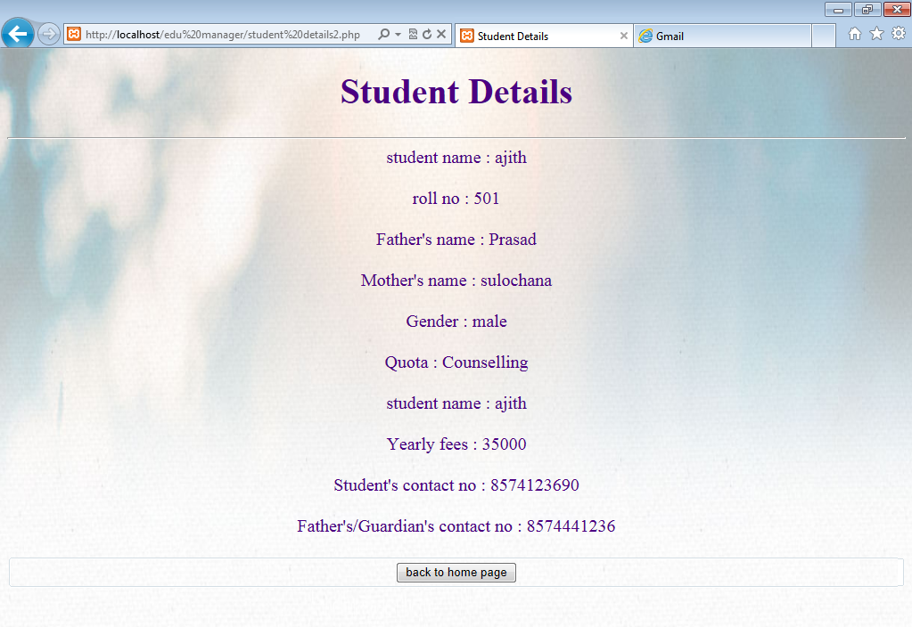

**6. CONCLUSION&FUTURE ENHANCEMENT**

**CONCLUSION**

We intend to make a user friendly website to store and retrieve records in an effective and efficient manner. The main objective of out project is achieved. The user can get records by a single click thus making it the most helpful for this generation, as time is the key aspect of our daily life.

**FUTURE ENHANCEMENT**

Improvements can be appended by changing the existing modules. In future we enhance our project by adding the fee payment feature. Our project which is now a web based application can be furtherdeveloped as a mobile application accessed with internet connection.